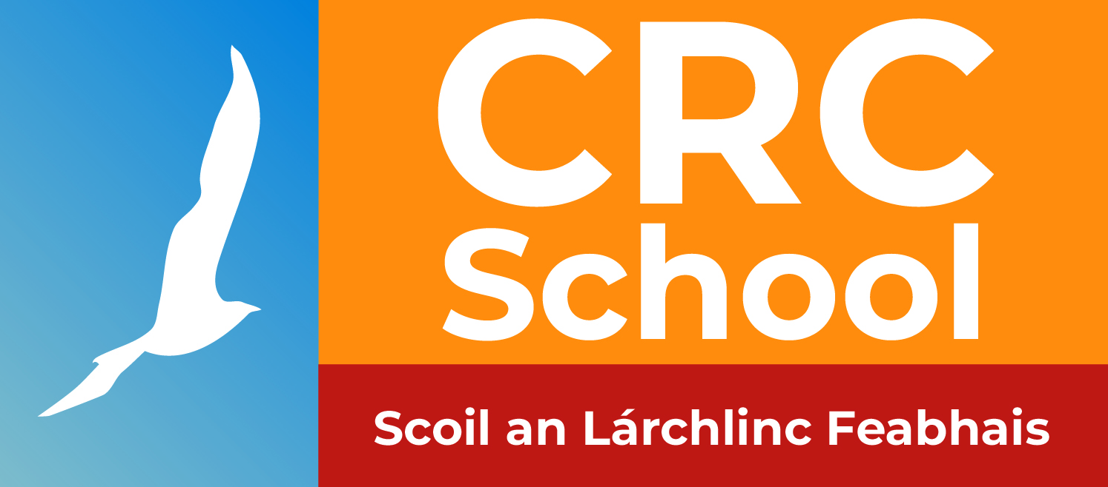
Principal: Mary Collins
Phone: 01 854 2230
Roll No: 18317f

CRC School

The CRC School is a special school which caters for children aged 3 – 18 years with a physical disability. Our school is divided into three sectors: Pre-School, Primary and Post-Primary. Our students come from all over north Dublin city and county. Many of our students have high medical needs and require a lot of one to one support.
Our preschool programme is a two-year programme and we use the Aistear Framework that is used in many other pre-school settings. Our Primary Classes use the Primary National Curriculum which is adapted to suit the needs of each child. In the post-primary classes, we follow many different programmes including JCSP, Junior Cycle, and QQI Levels 1, 2 and 3.
The CRC School is under the patronage of the CRC. The school receives nursing support from the Nursing Department. Children attending the school have the choice to avail of clinical services through the Clontarf CDNT or they can choose their home address to access these services. School transport is funded by the Department of Education and organised by Bus Eireann. In the first year of pre-school, the CRC fund transport – the CRC fund one bus and as such we cannot guarantee that each child in the first year of Pre-school will be catered for. Each year for Pre-school year one, we look at the addresses of the cohort of child. We also take into consideration the medical needs of each child.
Most children join the school in the pre-school classes, but some children join at different stages throughout the school. Some of our children leave to go to mainstream. When a student reaches 18 years of age they are classed as an official school leaver. The HSE works with the school to profile the student and to see what would be the best service for the student to transfer to when leaving school. CRC Adult Services offer a number of programmes. Some school leavers move onto other service providers.
When a parent is considering an educational setting for their child, it is best to think about what is most appropriate whether it is a mainstream setting, a special class setting in a mainstream school or a special school. Each setting has its benefits, but a parent must consider what setting is most supportive but least restrictive for their child. Our school has the following criteria for all applications:
- The child must have a diagnosed physical disability or multiple disability with physical being the primary disability;
- The child must be three years of age on entry to the school;
- The child must live in the school catchment area which is North City and County Dublin.
- For applications to the Primary or Post-Primary sector of the school, the child should be of sufficient cognitive ability to benefit from the programmes offered.
No matter how long or how short a child’s stay is in our school, we would hope to make their time here as productive as possible and to promote the well-being of the child.
If you are considering the CRC School for your child, please complete the form attached and return to the school along with any relevant reports for your child including a medical report outlining your child’s physical disability.

APPLICATION FORM
FOR ENROLMENT OF CHILD
IN CRC SCHOOL
2022 - 2023

Pupil’s Details

Name: ……………………………….. Date of Birth: ……………………………

Address: ……………………………. PPSN: ……………………...……….……

………………………………………... Nationality: ……………………...……….

………………………………………… Religion: ………………………………….

Eircode: ….…………………............... Language Spoken at Home: ……………..

Male Female

Mother’s Details  Name: …………………………………….  Address: …………………..……………...  ……………………………….……………  ……………………………….……………  Eircode: ………………….………………  Mobile No: ………………….……………  Email: ……………………….…...………  Nationality: ………….……..…………… | Father’s Details  Name: ……………………………………..  Address: …………………………………...  ………………………………………………  ………………………………………………  Eircode: ……………………………………  Mobile No: …………………………………  Email: ……………….……………...………  Nationality: …………..…….………………
Physical Disability:

Additional Disability:

Sight / Vision:

Hearing:

Communication / Speech:

Mobility:

Feeding Needs:

Toileting Needs:

Use of specialised equipment including communication devices, hoists, stander, specialised seating, walker:

Medication:

Additional Information:

Details of any Schools already attended:
Name of School:

School Principal:

Current Class Level:

Why you would like your child to attend the CRC School :

………………………………………………………………………………………………..........

……………………………………………………………………………………………………..

……………………………………………………………………………………………………..

……………………………………………………………………………………………………..

Does your child attend the CRC? Yes No

If you have answered yes, please name the professionals your child attends:

Consultant(s) : ………………………………

Physiotherapist: ……………………………..

Speech and Language Therapist: ………………………

Occupational Therapist: ……………………….

Does your child attend the FEDS Clinic? Yes No

If your child does not attend the CRC, please state your child’s current service provider :

……………………………………………………………….

Signed:________________________________ Date:_________________

Relationship to the child:……………………….

Please return the following to: CRC School, Vernon Avenue, Clontarf, D03 K298

Closing Date for Applications Friday February 18th 2022

Checklist For Parents

- Fully completed application form

- Copy of birth certificate

- Proof of address for child (utility bill within last 6 months)

- Professional Report(s) which:

- Outline the child’s physical disability

- Outline the child’s level of care needs including feeding, toileting, mobility and communication
- Recommend a special school educational setting

- Recommend additional SNA support
Not applicable to Pre-school Year 1 Applications
- Recommend that the child travel on school transport

- Recommend that the child requires a bus escort while
on school transport

The purpose of professional reports is to assist the school in establishing the educational needs of the child relevant to his/her disability or special needs and to profile the support services required. Additional reports may be requested from parents by the Medical Director and/or the School Principal.
GDPR: Please note, the CRC School cannot access reports from the CRC Medical Office for children who are not already pupils in the school and, therefore, all required reports must be included with this application.
Official Use Only
Date Application Received
All sections of application form completed | Yes | No
Proof of address provided and in date | Yes | No
Within catchment area | Yes | No
Birth certificate provided | Yes | No
Report outlining physical disability | Yes | No
Report outlining care needs | Yes | No
Recommendation for special school setting | Yes | No
Recommendation for additional SNA support | Yes | No
Recommendation for school transport and bus escort | Yes | No

