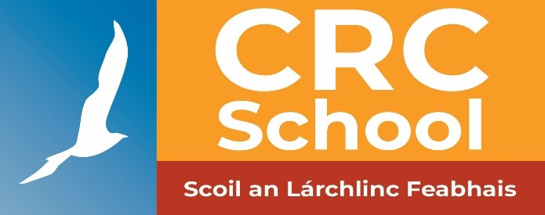

CRC SCHOOL
ANNUAL ADMISSION NOTICE
in respect of admissions to the 2024/2025 school year
Admission Policy and Application Form
A copy of the school’s Admission Policy and the Application Form for Admission for the 2024/2025 School Year is available as follows: –
On request:
By emailing : school@crc.ie
Or
By writing to : CRC School, Vernon Avenue, Clontarf, Dublin 3

PART 1 - Admissions to the 2024 / 2025 school year

Application and Decision Dates for admission to 2023 / 2024
The following are the dates applicable for admission to Pre-School Year 1

The school will commence accepting applications for admission on | 16/01/24
The school shall cease accepting applications for admission on | 09/02/24
The date by which applicants will be notified of the decision on their application is | 27/02/24
The period within which applicants must confirm acceptance of an offer of admission is | 15/03/24

Note: the school will consider and issue decisions on late applications in accordance with the school’s admission policy.

*Failure to accept an offer within the prescribed period above may result in the offer being withdrawn

Number of places being made available in 2024 / 2025

The number of places being made available in Preschool Year 1 is | 9

